1) #include<stdio.h>

#include<stdlib.h>

int main()

{

int a[]={40,42,44,43,46,41,47,45};

printf("Unsorted Array:");

int a1[]={40,42,44,43,46,41,47,45};

int n=8,i,j,bcount=0,icount=0,scount=0,temp,key;

for(i=0;i<n;i++)

{

printf("%d,",a[i]);

}

printf("\n");

//Bubble sort

for(i=0;i<n-1;i++)

{

for(j=0;j<n-i-1;j++)

{

if(a1[j]>a1[j+1])

{

temp=a1[j];

a1[j]=a1[j+1];

a1[j+1]=temp;

++bcount;

}

}

}

printf("Sorted Array under Bubble,Insertion and Selection Sort respectively\n");

for(i=0;i<n;i++)

{

printf("%d,",a1[i]);

}

printf("\n");

//Insertion sort

int a2[]={40,42,44,43,46,41,47,45};

int n1=8;

i=0;

j=0;

for(i=0;i<n1;i++)

{

key = a2[i];

j = i - 1;

/* Move elements of arr[0..i-1], that are

greater than key, to one position ahead

of their current position */

while (j >= 0 && a2[j] > key) {

a2[j + 1] = a2[j];

j = j - 1;

++icount;

}

a2[j + 1] = key;

}

for(i=0;i<n;i++)

{

printf("%d,",a2[i]);

}

printf("\n");

int min_idx;

int a3[]={40,42,44,43,46,41,47,45};

// One by one move boundary of unsorted subarray

i=0;

j=0;

for (i = 0; i < n-1; i++)

{

// Find the minimum element in unsorted array

min_idx = i;

for (j = i+1; j < n; j++) {

if (a3[j] < a3[min_idx]) {

min_idx = j;

}

}

// Swap the found minimum element with the first element

temp=a3[min_idx];

a3[min_idx]=a3[i];

a3[i]=temp;

++scount;

}

for(i=0;i<n;i++)

{

printf("%d,",a3[i]);

}

printf("\n");

int item;

i=0,j=0;

//Linear searching

printf("Enter an item to be found.\n");

scanf("%d",&item);

for (i = 0; i < n; i++)

{

if (a[i] == item)

{

printf("Item found at position %d\n",(i+1));

break;

}

}

printf("Number of swaps in Bubble sort:%d\n",bcount);

printf("Number of swaps in Insertion sort:%d\n",icount);

printf("Number of swaps in Selection sort:%d\n",scount);

return 0;

}

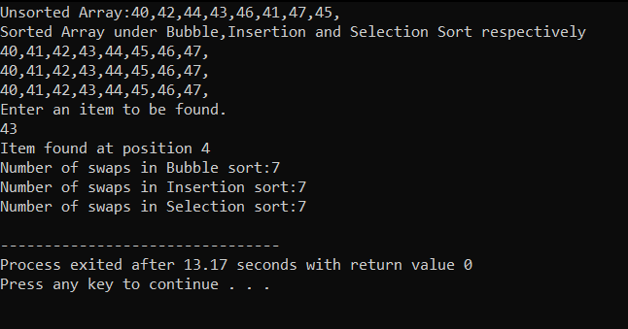

2) #include<stdio.h>

#include<stdlib.h>

#include<string.h>

int a[4][4];

void job(int a[4][4],int n)

{

int i,j,k,amt=0;

for(i=0;i<n;i++)

{

int min=100;

for(j=0;j<n;j++)

{

if(a[j][i]<min)

{

min=a[j][i];

k=i;

}

}

amt=amt+min;

}

printf("Cheapest cost:Rs.%d",amt);

}

int main()

{

int i,j,n;

printf("Enter the size of array:");

scanf("%d",&n);

for(i=0;i<n;i++) //Enter n as 4 and array as {9,2,7,8},{6,4,3,7},{5,8,1,8},{7,6,9,4}

{

for(j=0;j<n;j++)

{

printf("Enter element:");

scanf("%d",&a[i][j]);

}

}

job(a,n);

return 0;

}

